## How Do I Get Started

The Firm Administrator sets you up in LTWeb, with a username, and an email address to which you have agreed. Your login is linked to the appropriate property or properties. You then receive an email inviting you to log in. Using the link (aka URL) for LTWeb that is provided in the mail, you connect with a web Browser (we use Chrome) to the application. You see a login screen similar to the following:

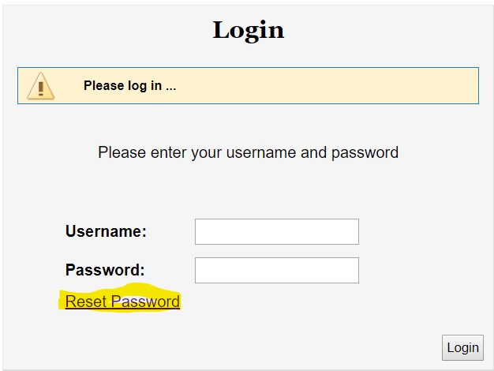

Figure 1

The very first time you see the screen, click Reset Password, so that you can enter your personal password to LTWeb.

**Note: There is a 30-minute inactivity timeout on your session. If LTWeb sits idle for 30-minutes, you will have to log in again.**

Enter your username and email address as provided by the Firm Administrator, and click Submit.

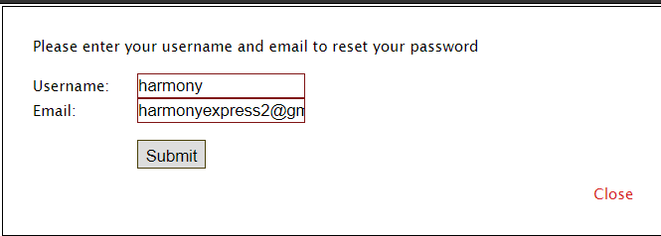

You will receive an email in about a minute with a initial password that has been assigned to your login.

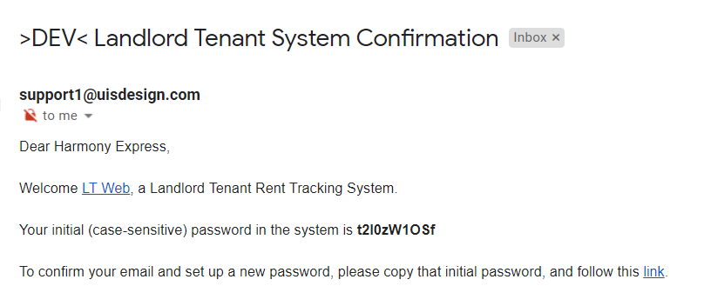

Copy the initial password, and click on the link.

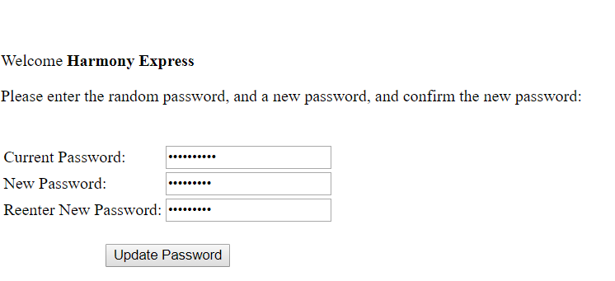Paste the initial password into the Current Password field, and enter your desired password into each of the next two fields, and click Update Password.

You then get the login screen back, where you can enter the new password you just defined. Then click Login, to go to the Home Screen

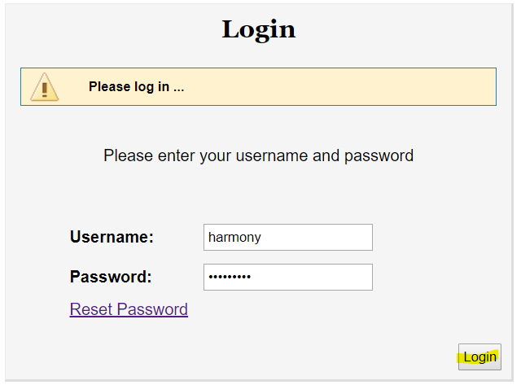

## Home Screen

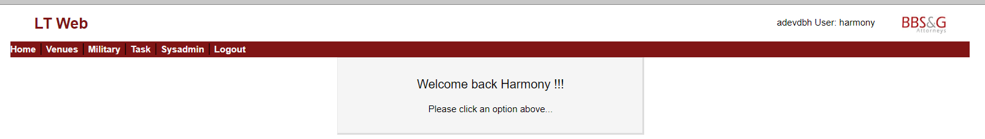

Figure 2

## Menu Options

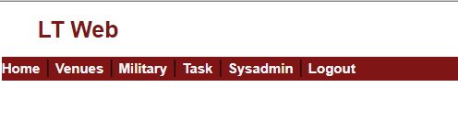

Figure 3

**Home** – presents the screen above. This option is hardly ever selected.

**Venues** – goes to a table of venues, and properties within Venues. This is where you do most of your work. Within this area you add, change, and delete venues, properties, users (logins), as well as process cases through 10 queues.

**Military**– shows a menu of options for interfacing with the Servicemembers Civil Relief Act (SCRA) website. This site provides verification of military status, based on a tenant’s name, and date of birth or social security number.

**Task** – is available for users with appropriate permission. It provides options for looking at two background processes: (updater) interacts with File and Serve Express to submit cases, and receive back case numbers, submit writs, etc., and (workqueue) which provides reports, without making the user wait while the report is generated.

**Sysadmin**  – provides the software admin a way to perform various maintenance chores.

**Logout** – saves the selections you have made, and returns to the login prompt. Select this option when leaving your terminal even for a few minutes – for security reasons.